



Tech Mahindra
Response to RFP


RQM TO JENKINS INTEGRATION

Table of Content
1. RQM-Jenkins Integration 5
1.1. Installation of Command Line Adapter 5
1.2. Pre-Requisites 5
1.3. Procedure 5
1.3.1. Results 7
1.3.2. Verification 7
2. Triggering Jenkins job from command line adapter in RQM: 9
2.1. Output file: 14

RQM-Jenkins Integration

Installation of Command Line Adapter

Pre-Requisites
Before running this adapter, please make sure that
- Java.exe is accessible in the path. The version of JAVA required is 1.5 or later
- The input information is available to start the adapter, namely
- the Jazz repository URL, typically http://<qmserver>:<port>/qm
- a user ID to login to RQM that has appropriate licenses to login as an adapter
- the password or this user
- the project area to which the adapter is being logged in

Procedure
- Obtain the install-location\server\conf\qm\adapters\RQMCommmandLineAdapter.zip file from the installation machine

A server administrator who has read access to the server might need to get the compressed file for you.

- Extract the RQMCommmandLineAdapter.zip file to a folder on the target test machine.
- Start the command-line adapter.
- To start the command-line adapter for the first time:

Run the batch file with the command line arguments as shown:
C:\ start.bat -repository https://qmserver:port/qm -user userid -password [-adapter adapter] [-project Area project area] [-sleepTime sleeptime] [-configFile configuration file]

Here the command is as follows:
E:\RQMCommandLineAdapter>start.bat -repository https://bsd-pc1528497:9443/qm -user clmadmin -password clmadmin -adapter Adapter87 -projectArea POC-RQM-CQ [-sleepTime 10][-configFile config.ini]

Where:
- Qmserver: is the hostname or IP address of the quality management server.
- Port: is the port where the quality management server is running
- User id: is a registered user ID for quality management that has the license to run an adapter.
- Password: is the password of the submitted user ID.
- Adapter: is an adapter name that the user has assigned.
- Project area: is the name of the project being logged in to.
- Sleep time: is the polling interval between polling for tasks. The default setting is 5 seconds.
- Log file: is the file that logs output messages. The default file name is CommandLineAdapter.log.
- Configuration file: is the file to store and read the settings for this adapter. The default files name isconfig.ini.
The adapter generates a configuration file (the config.ini file or the file that is specified in the -configFile option) to contain the registration information. This information is reused when the adapter is restarted.
You will see the following output when the adapter is created:
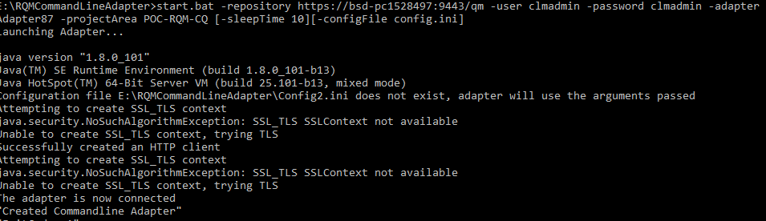
To restart the command-line adapter from a config.ini file:
Run the batch file (start.bat) without any arguments:

The configuration file is expected to be in the directory that the adapter is started from.

Results
The system generates a message that is similar to this message:
Launching Command Line Adapter…
Configuration file adapterConfig.ini does not exist, adapter will use the arguments passed
Successfully created an HTTP client
The adapter is now connected

Verification
You can verify the adapter state on the quality management application on the tester machine by clicking Execution > Adapter Console. Make sure the status is GREEN before you attempt to run a test against a running command-line adapter.

Once you install the Command Line Adaptor then you configure in the Jenkins as per below.

To Trigger Jenkins build from command line some perquisite are there
- Jenkins service is running.
- Enable security option under “Configure Global Security”
Go to Jenkins dashboard in Home page (e.g. http://localhost:8080/) -> Manage Jenkins
-> Configure Global Security -> Click on “Enable security” checkbox
You can also configure “Access Control” and “Authorization” option in Global Security page.
Jenkins allows us to trigger Jenkins build with any specific user, for that we have to pass username and password in command line.
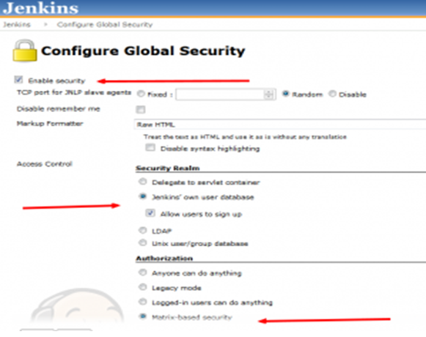

Below command used to trigger Jenkins job from command line
Java -jar jenkins-cli.jar -s http://localhost:8080/ build 'my-project-build' --username admin --password admin
Here the command used is:
Java -jar jenkins-cli.jar -s http://localhost:7777/ build Test1 --username admin --password admin

Triggering Jenkins job from command line adapter in RQM:
Before running a script to trigger Jenkins through command line adapter, make sure that you place Jenkins-cli.jar and the script file to trigger Jenkins from command line in the installation folder of Command Line Adapter.
Note: Script (batch file to trigger Jenkins) and jenkin-cli.jar should be in the same folder.
Create a test script and change the type to Command Line, as shown in figure.
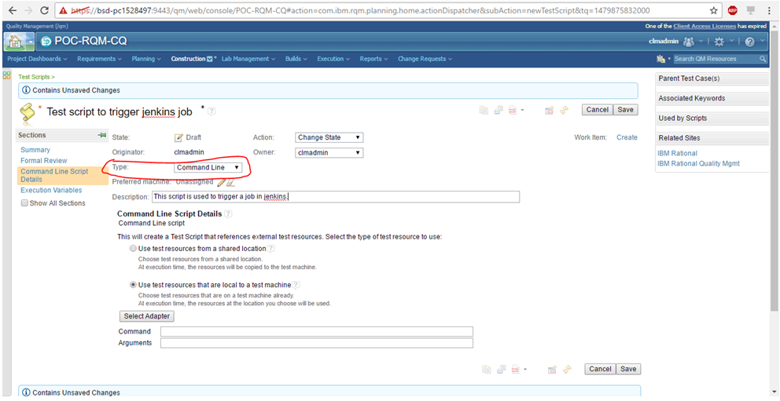
Click on Select Adapter to select the adapter you have installed.
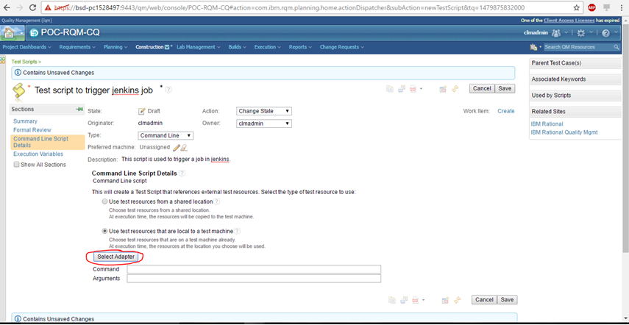

You can see the list of adapters available. Select the Adapter you wish to use and click on Next.
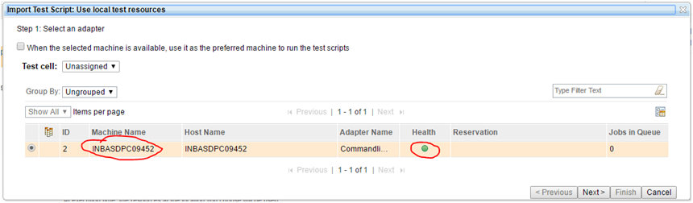

In Project Path field, give the path where the script and Jenkins-cli.jar are present.
Click on Go. (Here the path is Adapter installation folder)
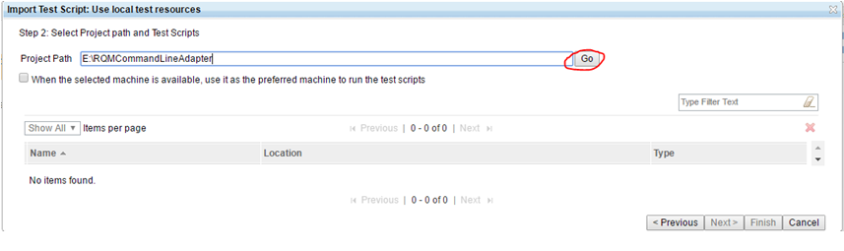
The next screen will display all the files present in the path you have provided.
Select the script which triggers the job in Jenkins.
Click on Finish
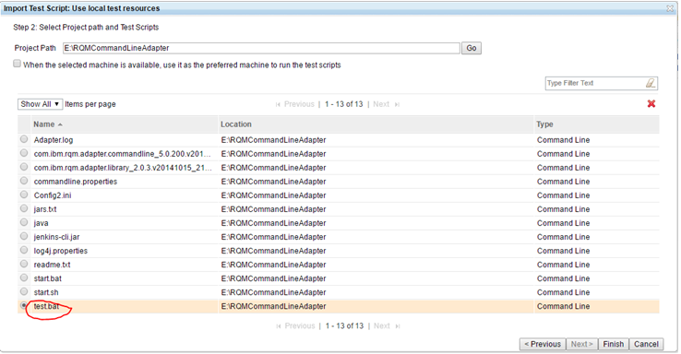
Create a test case and assign the test script which you have just created and run the test case.
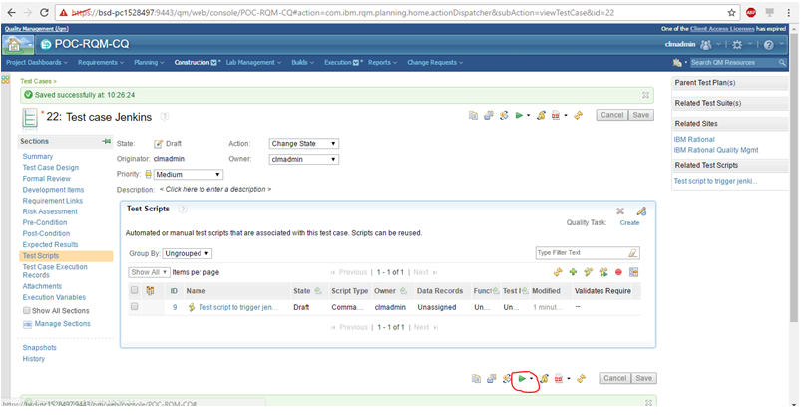

Provide the details in the Define Record Details window and Click Finish.
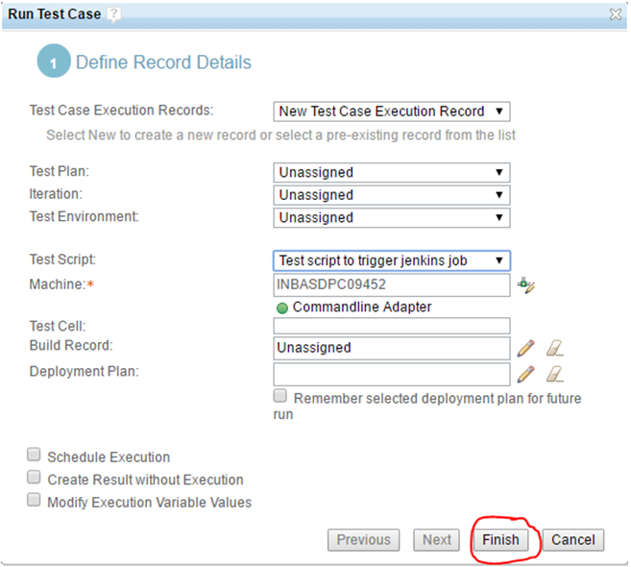

You can see that the test script is running.
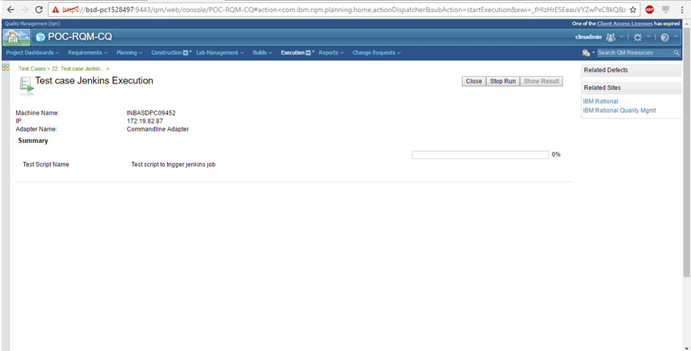

When the test script is executed, you can see the status as done.
Click on Show Result to view the results of test script execution.

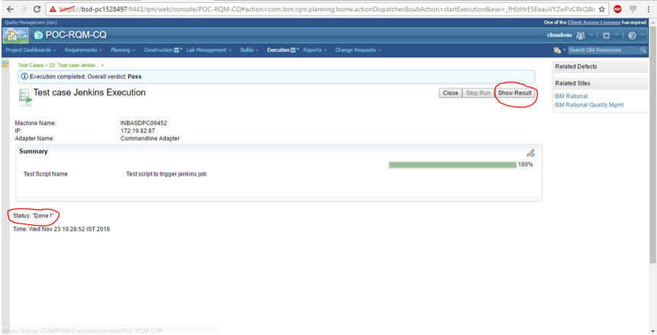

You can also view the output file in attachments.
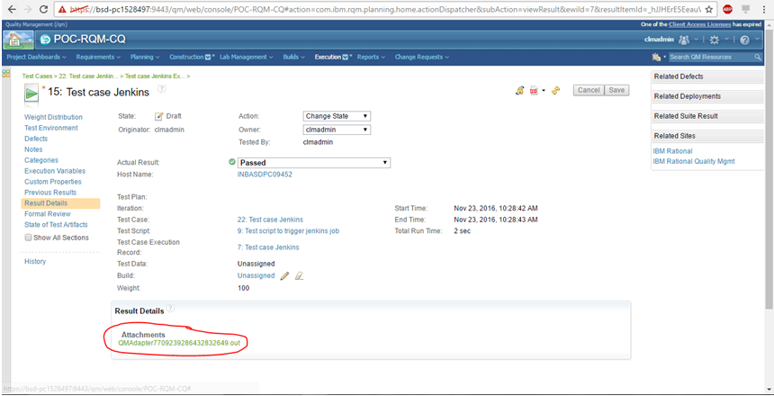

Output file:
You can see that job is triggered in Jenkins.
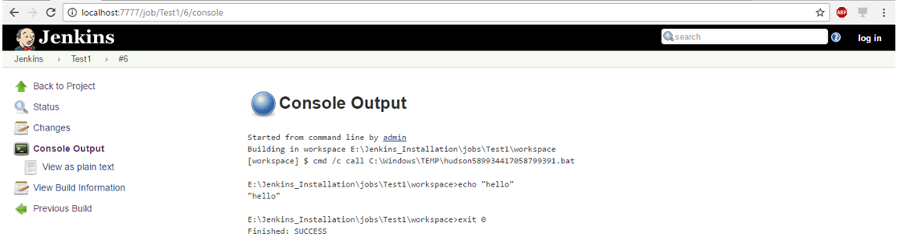

Disclaimer
Tech Mahindra, herein referred to as TechM provide a wide array of presentations and reports, with the contributions of various professionals. These presentations and reports are for informational purposes and private circulation only and do not constitute an offer to buy or sell any securities mentioned therein. They do not purport to be a complete description of the markets conditions or developments referred to in the material. While utmost care has been taken in preparing the above, we claim no responsibility for their accuracy. We shall not be liable for any direct or indirect losses arising from the use thereof and the viewers are requested to use the information contained herein at their own risk. These presentations and reports should not be reproduced, re-circulated, published in any media, website or otherwise, in any form or manner, in part or as a whole, without the express consent in writing of TechM or its subsidiaries. Any unauthorized use, disclosure or public dissemination of information contained herein is prohibited. Unless specifically noted, TechM is not responsible for the content of these presentations and/or the opinions of the presenters. Individual situations and local practices and standards may vary, so viewers and others utilizing information contained within a presentation are free to adopt differing standards and approaches as they see fit. You may not repackage or sell the presentation. Products and names mentioned in materials or presentations are the property of their respective owners and the mention of them does not constitute an endorsement by TechM. Information contained in a presentation hosted or promoted by TechM is provided “as is” without warranty of any kind, either expressed or implied, including any warranty of merchantability or fitness for a particular purpose. TechM assumes no liability or responsibility for the contents of a presentation or the opinions expressed by the presenters. All expressions of opinion are subject to change without notice.

Thank You
Visit us at www.techmahindra.com

